Семей қаласының 37-гимназиясының ағылшын тілі пәні мұғалімі
Шаймуратова Гульнара Бериккановна

The subject: English
The theme:Туған жер
Grade: 7⁻form
Aims: to motivate pupils to speak on the theme
Objects:
Educational:
- to teach pupil to offer their opinion on the given topic and to explain the use of new grammar;
- to receive topical vocabulary;
- Teach to love motherland and wake the patriotic feeling;
- to be able to protect it and to be an individual citizen of our country.
Developing:to develop pupil’s speaking, reading and logical thinking skills.
Bringing up:
- To teach pupils to listen and respect the other’s opinion
- to teach pupils to work in group and on their own.
The form ofthe lesson:traditional lesson
The methods of teaching: discussion, question-answer, informational.
Visual aids: whiteboard, pictures, tables, books, videos.
Inter subject connection: Kazakh, geography, history and music.

The Procedure of the Lesson

I. Organization moment.
- Good morning boys and girls! Sit down please!I’m glad to see you! How are you? Who is on duty today? What date is it today? Who is absent? Ok, before starting let’s song our national anthem.
II.Checking up the homework.
What was your home task? What did you do in the last lesson?
Let’s revise our last topic.

Main part.
1. Introducing new theme
- Today we are going to work with the theme “Kazakhstan is my motherland!”To show presentation according to new topic. And introduce with new vocabulary. Make children write unknown words.What is capital of our country? What are main emblems do you know? Ok, let’s see a video about Kazakhstan

Consolidation with new words.
Share- бөлісу
Desert -құмдыдала
Resources -байлықресустар
Uranium -уран
Deposit жерастықоры
Gas- газ
Rename - жаңаатберу

2. Working with books:
- Now let’s move to the ex.1. Read and translate.
KAZAKHSTAN IS MY MOTHERLAND
Kazakhstan was established as the Republic of Kazakhstan in December 1991. The country is the second largest of the former Soviet republics with a total land area of over 2, 724. 900 million square kilometers. This country shares its border with the Russian Federation to the north and north - west; to the east with China and to the south with the central Asian republics of Kirgyzstan Uzbekistan and Turkmenistan.
The Ural River flows through the western portion of Kazakhstan to the Caspian Sea. The central region of the country includes the Kazakh Steppe to the north and deserts of central Asia in the south - west. The Altai mountains can be found in the east….

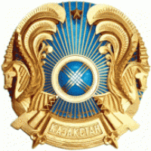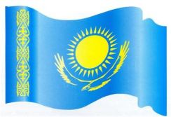

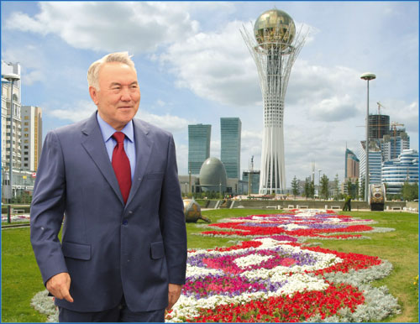
General data
Area: 2. 724. 900sq. km.
Capital: Astana
Population: 16, 870, 000
Largest cities: Almaty (1. 3 mln -) Karaganda (0. 633 mln-),Shymkent (0. 5 mln -)

Ex 2.

Talk to your partner.
What is the population of Kazakhstan?
What large cities of Kazakhstan do you know?
What countries does it border on?
What are the places which are polluted?
Where is the Republic of Kazakhstan situated?
What is the size of KZ.? (the area is 2. 753 square km)
What can you say about the population of our country? (about 16)
Who is the head of the state? (the president)
When did Kazakhstan become an independent state? (in 1991)
What are the symbols of the state? (national flag, emblem and anthem)
What does the blue color of the flag symbolize? (freedom, independent)
What is represented on the state flag? (sun, falcon, ornament)
What kind of state is KZ? (independent, democratic)

3.Relaxation time. I see you are tired. Stand up! Put your hands up! Put your hands down! Shake your head! Look up! Look down! Look left! Look right! Look at your nose! Look at your neighbor! Smile!

III. Summary of the lesson. (3-5 min)
- Today you were so active and worked very hard. Was the lesson interesting? Were you enjoyed during the lesson? What have you learned from this lesson? (You’ve learned new words, used them while speaking, worked actively in groups and I think you got pleasure from this lesson.)
- Thank you.
1)Home task: To learn the new words. Exercise 5 write out the sentences from the text “KAZAKHSTAN IS MY MOTHERLAND”

2)Evaluation of students answers.

