Short-term plan

Unit of a long term plan:  Unit 9. The World of Work |  |  | School: The Economic Lyceum
Date: 13.05.2019 |  |  | Teacher`s name: Berkova T.A.
Grade: 8 |  |  | Number present: | absent:
Theme of the lesson: A job interview

Learning objective(s) that this lesson is contributing to |  | 8.3.5.1 (8.S5) interact with peers to negotiate, agree and organise priorities and plans for completing classroom tasks  8.4.6.1 (8.R6) recognise the attitude or opinion of the writer on a growing range of unfamiliar general and curricular topics, including some extended texts  8.6.5.1 (8.UE5) use questions which include a variety of different tense and modal forms on a range of familiar general and curricular topics
Lesson objectives |  | All learners will be able to:
- complete KWHLAQ chart about a job interview
- identify the meaning of the advert “Sales Assistant Wanted”
- practise the new vocabulary and useful phrases
- listen to the dialogue “A job interview” and complete the sentences with the missing words
- act out the dialogue, record it and evaluate each other
- listen to the candidate`s tips about a good job interview and design a graphic organizer
 |  | Most learners will be able to:
 |  | - express their thoughts and ideas about the main principles of a good job interview
 |  | Some learners will be able to:
 |  | - play “Job Interview Game” in front of the class
Language objectives |  | Topical vocabulary: sales assistant, quality, position, enthusiasm, candidate, part-time and full-time job, apply for, straightway. Useful phrases of Everyday English
Assessment criteria |  | - Complete KWHLAQ chart  - Listen to the dialogue and complete the sentences with the missing words  - Write the missing words correctly  - Act out the dialogue and record it  - Present the candidate`s tips about a good job interview using a graphic organizer  - Share their ideas about the main principles of a good job interview  - Play “Job Interview Game” in front of the class
Level of thinking skills |  | - Knowledge  - Comprehension  - Application  - Evaluation
Value links |  | Respect for each other and for the teacher. Cooperation. Academic honesty. These values can be fostered through individual, pair and group work.
Cross curricular links lin |  | Social Studies, PE
Previous learning |  | Choosing Career
Materials and equipment |  | Базовый УМК - “EXCEL” (for Kazakhstan), Grade 8  Virginia Evans, Jenny Dooley, Bob Obee  (Express Publishing), 2018 (SB), Track 1, Track 2, index cards with synonyms, mobile phones, realia (bow tie, tablet folder), Handouts
Plan
Planned timings | Planned activities |  |  | Resources
Start  (7 min)  2 min  1 min  1 min  3 min | Preparation: Before the beginning of the lesson SS are divided into 3 groups of 4 by using synonym word cards. Teacher has sets of synonyms written on different index cards and passes them out. Then SS find the other person in the classroom who has the word that means the same as their card.  Synonyms: job-place, position, post; candidate – applicant, nominee, contestant; CV - biography, resume, work history; employer – boss, director, owner.  [W,I,G] Leading-in stage  1. Greeting. Phonetic drill.  Good morning, children! Glad to see you here. How are you?  [I,G] Let`s start our lesson with these tongue twisters where professions are mentioned (1 tongue twister for each group).  SS practise the tongue twisters individually and in groups.  1) The cook took a good look at the cookery book.  2) A fisherman wished a good fish.  3) If one doctor doctors another doctor,  Then which doctor is doctoring the doctored doctor?  4) She saw sheriff's shoes on the sofa.  2. Links with previous learning.  [W,I] After phonetic drill teacher asks SS to answer the questions: What was the theme of our previous lesson? What is CV? What information can be included in CV?  3. Teacher introduces the lesson objectives.  4. Warm-up.  [I,W] Teacher asks SS to complete KWHLAQ chart about a job interview. Some SS share their ideas (1 from each group). SS will complete the 4th and 6th columns of the chart at the end of the lesson.  KWHLAQ chart  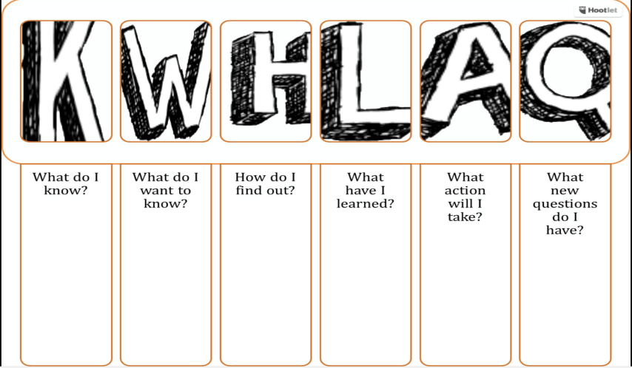  Assessment: teacher gives SS positive feedback on their answers. |  |  | https://www.thesaurus.com/browse/job  https://www.thesaurus.com/browse/candidate  https://www.thesaurus.com/browse/cv  https://www.thesaurus.com/browse/employer?s=t  Tongue twisters  Handout 1
Middle  (29 min)  2 min  5 min  1 min  4 min  3 min  6 min  4 min  4 min | [I,W] Brainstorming  Teacher asks SS to read the advert “Sales Assistant Wanted” and answer the questions:  Who is the employer looking for? What are working hours according to the advert? What personal traits should the candidate have?  Listening  Pre-listening tasks  [I,W] Task 1. Teacher offers SS to practise the pronunciation of new words and useful phrases (chorally and individually)  Topical vocabulary: sales assistant, quality, position, enthusiasm, candidate, part-time and full-time job, apply for, straightway.  Useful phrases of Everyday English:  Why do you want to work for us?  I was hoping to earn some extra money during the holidays.  Do you think you have the qualities necessary for the position?  It`s good to hear your enthusiasm!  There are number of other candidates.  Thank you for your time.  I`m looking forward to hearing from you.  Teacher encourages SS to pick up unknown words in dictionaries and put them down.  [I,W] Task 2. Teacher asks SS to predict the content of the dialogue according to these useful phrases. SS answer the questions:  What can you say about the candidate? Why does the candidate apply for this position? Did this candidate get a job?  While-listening task  [P,G] Task 3. Work in pairs. Teacher offers SS to listen to the dialogue “A job interview” and complete the sentences with the missing words. No more than two words.  Keys. 1) good grades; 2) extra money; 3) the ad; 4) applied straightaway; 5) the qualities; 6) hard-working; 7) communication skills; 8) enthusiasm; 9) other candidates 10) decision.  After getting the task done SS check their partner`s answers and then share them with the group members.  Differentiation by support:  Weaker students will be supported by their partner.  Peer assessment  SS assess each other using the assessment sheet.  Descriptors  A learner:  - completes the sentences with the missing words;  - writes the missing words correctly.  Filler. Word Train. SS should stand in the line and name the words of the topical vocabulary or useful phrases in turn. If S gives the right answer, he/she`ll go to the end of the Word Train. If S doesn`t know the word or phrase, he/she is expelled out of the Train.  Post-listening task  [P,G] Task 4. Teacher asks SS to act out the dialogue and record it using their mobile phones. Then SS swap their mobile phones in group and play the recording and evaluate each pair according to the assessment sheet.  Differentiation by support:  Weaker students will be supported by their partner.  Peer assessment  SS assess each other in the group according to the assessment sheet.  Descriptors  A learner:  - pronounces the new words clearly;  - uses the right intonation in compound nouns;  - makes up grammatically correct sentences.  Listening and Speaking  [P,W] Task 5. Think-Pair-Share. Teacher offers SS to listen to the candidate`s opinion about the job interview and answer the question: What tips did the candidate give?  SS should design the graphic organizer to take notes on their ideas (while listening to the recording) and present it to the class.  Possible answers.  It’s really important to prepare.  You must also be confident and make sure the interviewer knows you really want the job.  The trick is to make the interviewer think you are the best person for the job.  I always wear my best suit and arrive early.  I always smile when I walk into the interview room. First impressions are very important.  It’s also a good idea to talk about your experiences - sell yourself.  Differentiation by scaffolding and difficulty of task:  Less able SS should be supplied by prompts.  More able SS may present their own ideas about the main principles of a good job interview.  Assessment: teacher gives SS positive feedback on their answers.  Speaking  [P,G] Task 6. “Job Interview Game”.  Teacher asks SS to play “Job Interview Game” in front of the class using realia.  Differentiation by support:  Weaker students will be supported by their partner.  Peer assessment  SS assess each other using the assessment sheet.  Descriptors  A learner:  -uses new vocabulary and useful phrases according to the topic;  - pronounces the new words clearly;  - uses questions which include a variety of different tense and modal forms;  - makes up grammatically correct sentences. |  |  | Student`s Book, Grade 8, Module 9. p.106  Handout 2  Student`s Book, Grade 8, Module 9. p.106.  Track 1. Grade 8, Module 9.  Handout 3  Assessment sheet 1  Assessment sheet 2  Track 2  https://listenaminute.com/j/job_interviews.html  Handout 4  Assessment sheet 3
End  (4 min)  3 min  1 min | Reflection  Teacher comes back to lesson objectives and finds out together with SS what they have learned and what new questions they have.  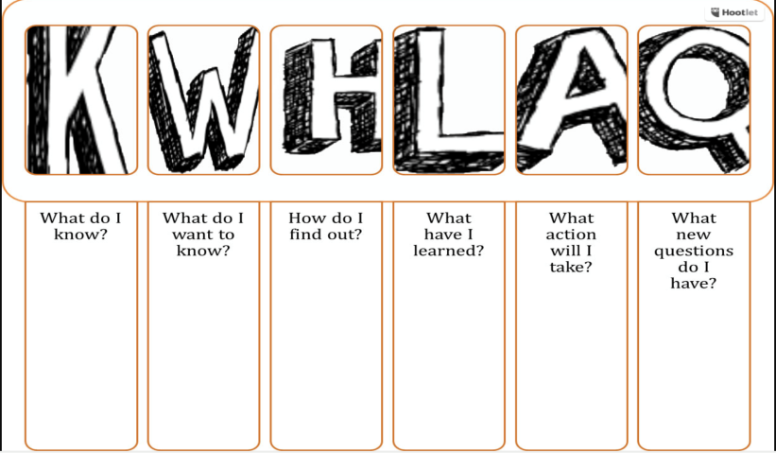  Home task:  Differentiation by difficulty of task:  1) Learn the words and useful phrases.  Work in pairs. Describe the main principles of a good job interview and present them to the class.  *2) Learn the words and useful phrases.  Work in groups. Make up 14 Job Interview Questions and present them to the class. |  |  | Handout 1

Tongue twisters
1) The cook took a good look at the cookery book.
2) A fisherman wished a good fish.
3) If one doctor doctors another doctor,
Then which doctor is doctoring the doctored doctor?
4) She saw sheriff's shoes on the sofa.

Handout 1
KWHLAQ chart 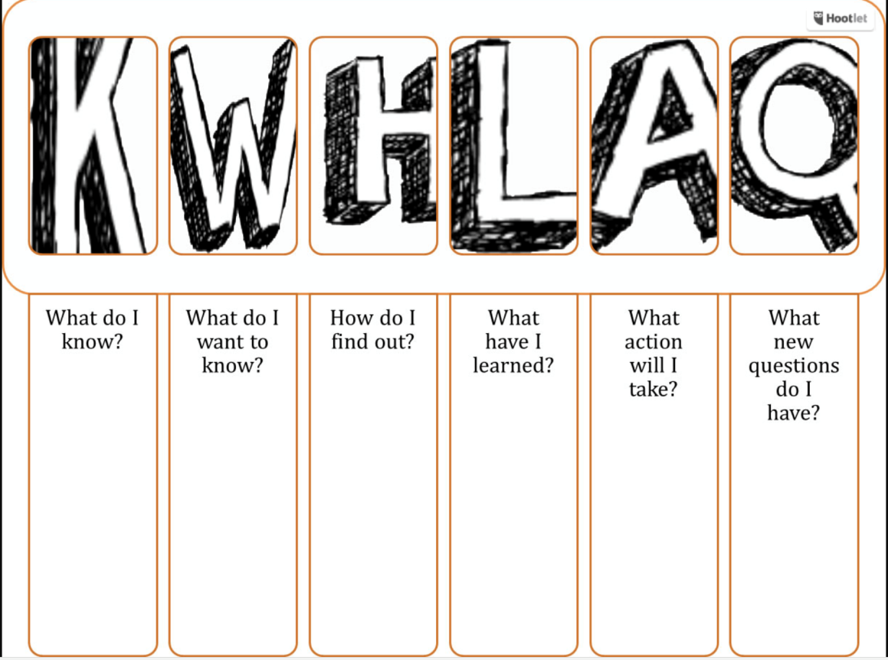
Handout 2
Sales Assistant Wanted
Job: part-time sales assistant at Harry`s Store in the city centre.
Work Hours: Saturday 9-4, Sunday 10-3. Applicants must be hard-working, enthusiastic and ready to start straightaway.
Send your CV to jobs@harrys.co.uk.

Handout 3
A job interview.
Employer: Hello, Roberta. Come in and sit down.
Candidate: Thank you.
Employer: Now, I have your CV here. I can see that you are 17 and go to Teddington School, and get 1) …. However, what I`d like to know is: why do you want to work for us?
Candidate: Well, I was hoping to earn some 2) … during the holidays. So when I saw 3) … in the newspaper for a part-time sales assistant, I 4) ….
Employer: Do you think you have 5) … necessary for the position?
Candidate: Yes, I do. I am 6) …, honest and patient. I also have good 7) …. Also, because I really like the things I will sell, I think I will be good at it!
Employer: It`s good to hear your 8) …! However, there are a number of 9) ... I will call you tomorrow and let you know our 10) ….
Candidate: Thank you for your time. I`m looking forward to hearing from you.

Handout 4

Task 5. The candidate`s tips.
It’s really important ________.
You must also be ________ and make sure the interviewer knows you _________.
The trick is to make the interviewer think you are _________.
I always _______ and arrive ______.
I always ______when I walk _________. First impressions are ________.
It’s also a good idea to talk about your experiences - __________.

Keys.
Dialogue between an employer and Roberta.
Employer: Hello, Roberta. Come in and sit down.
Candidate: Thank you.
Employer: Now, I have your CV here. I can see that you are 17 and go to Teddington School, and get good grades. However, what I`d like to know is: why do you want to work for us?
Candidate: Well, I was hoping to earn some extra money during the holidays. So when I saw the ad in the newspaper for a part-time sales assistant, I applied straightaway.
Employer: Do you think you have the qualities necessary for the position?
Candidate: Yes, I do. I am hard-working, honest and patient. I also have good communication skills. Also, because I really like the things I will sell, I think I will be good at it!
Employer: It`s good to hear your enthusiasm! However, there are a number of other candidates. I will call you tomorrow and let you know our decision.
Candidate: Thank you for your time. I`m looking forward to hearing from you.

1) good grades; 2) extra money; 3) the ad; 4) applied straightaway; 5) the qualities; 6) hard-working; 7) communication skills; 8) enthusiasm; 9) other candidates 10) decision.

Task 5. Transcript.

Job interviews are always hit and miss for me. Sometimes I have a great interview and get the job. Other times, my interview bombs and I don’t get the job. It’s really important to prepare. You must also be confident and make sure the interviewer knows you really want the job. The trick is to make the interviewer think you are the best person for the job. I always wear my best suit and arrive early. I always smile when I walk into the interview room. First impressions are very important. It’s also a good idea to talk about your experiences - sell yourself. Make sure you have a few good questions to ask at the end of the interview. Interview technique is something we learn over time – you get to relax more the more interviews you have.

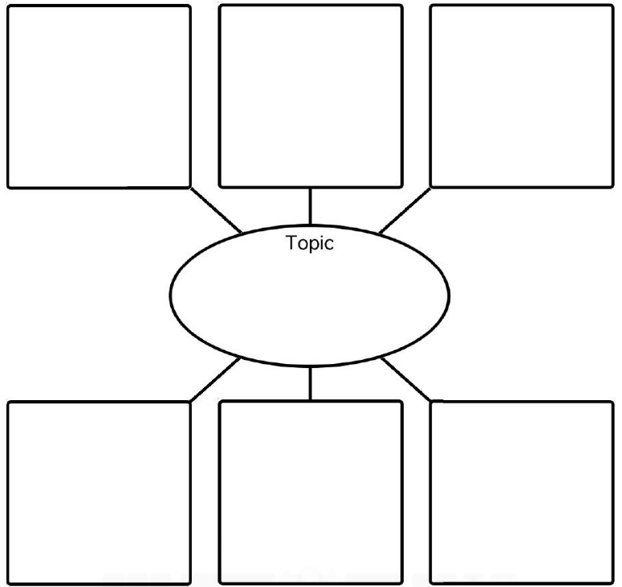
Graphic organizer

Assessment sheet 1 Grade 8
……………………………………(name) can: Theme: A job interview. While-listening task (3)
 | very well | OK | not very well
complete the sentences with the missing words
write the missing words correctly

Assessment sheet 2 Grade 8
……………………………………(name) can: Theme: A job interview. Post-listening task (4)
 | very well | OK | not very well
pronounces the new words clearly
uses the right intonation in compound nouns
makes up grammatically correct sentences

Assessment sheet 3 Grade 8
……………………………………(name) can: Theme: A job interview. Speaking (6)
 | very well | OK | not very well
uses new vocabulary and useful phrases according to the topic
pronounces the new words clearly
uses questions which include a variety of different tense and modal forms
makes up grammatically correct sentences

