Module 3: Treasure and Heritage  3. LESSON:  Theme: Treasure map. Numbers |  | School: 18
Date:12.11.2019 |  | Teacher’s name: Akramkhodzhaeva R.Z
CLASS: 4 «V» |  | Number present:15 | absent:
Learning objectives(s) that this lesson is contributing to | 4.3.3.1 recognise basic opinions in short, simple texts on an increasing range of general range of general and some curricular topics;  4.4.1.1 plan, write and check sentences with support on a range of basic personal, general and some curricular topics;  4.5.2.1 use ordinal numbers 1 – 100 and cardinal numbers 1 – 1000
Lesson objectives | All learners will be able to: use cardinal numbers 1 – 1000 and ordinal numbers 1 – 100; answer the questions about what they can see in the pictures.
 | Most learners will be able to: use cardinal numbers 1 – 1000 and ordinal numbers 1 – 100; answer the questions about what they can see in the pictures; make a
 | Some learners will be able to: use cardinal numbers 1 – 1000 and ordinal numbers 1 – 100; answer the questions about what they can see in the pictures ; act out the story
Assessment criteria | To develop creative thinking/ imagination, listening and speaking skills
Language focus | Language in use: Where is the treasure?
Target vocabulary | Numbers from 1 to 1000 and colours
Cross - curricular  links | Mathematic and drawing
Plan
Planned timings | Planned activities (replace the notes below with your planned activities) |  |  | Time
Greeting | Good afternoon, dear friends !  How are you?  What is the weather like today?  Do you like this kind of the weather ? |  |  | 1 min
Warm up activity | It`s time to think  It`s time to speak  It`s time to show  Ready steady GO!  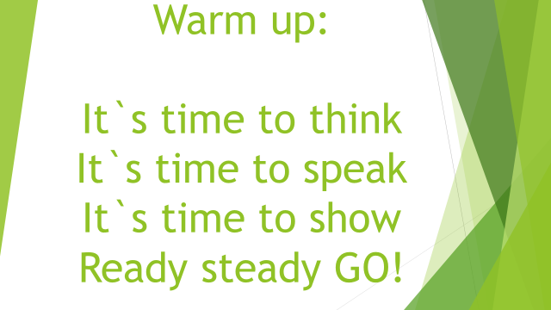 |  |  | 2 min
Divide into groups | All pupils one by one stand up come to the teacher`s table and choose coloured leaves then take their seats according to the chosen colours. |  |  | 4 minutes
Guessing the theme of the lesson | After taking a place pupils find big envelopers with picture puzzles on their`s desks. They open it and make a puzzle.  Then guess the theme of the lesson.  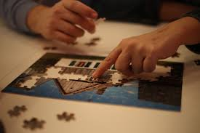 |  |  | 5 min
Names of the groups | Pupils make names of their groups with papers. Draw a symbol of their group  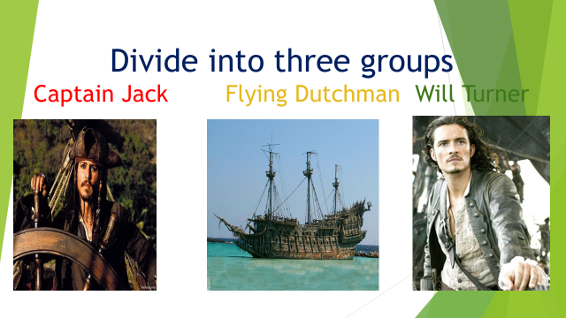 |  |  | 5 min
Treasure map | Pupils create their own map of treasure  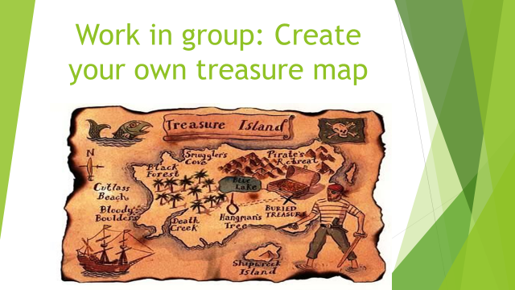 |  |  | 5 min
Assessment | Groups assess map by themselves then another group assess them. Then fill assessment list two stars and one wish  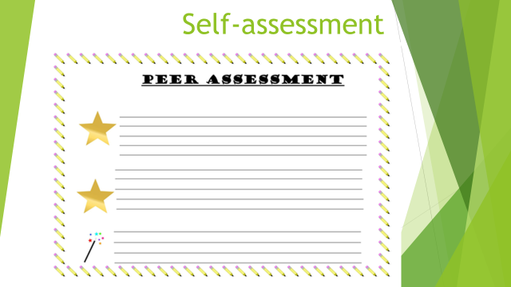 |  |  | 4 min
Physical minute | Pupils do physical exercises  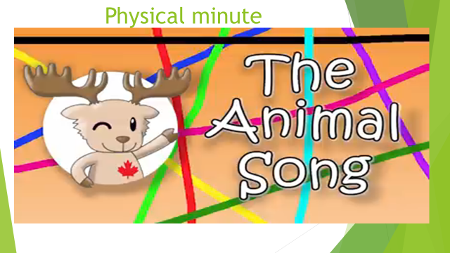 |  |  | 2 min
Practice | Groups do sums, and get points  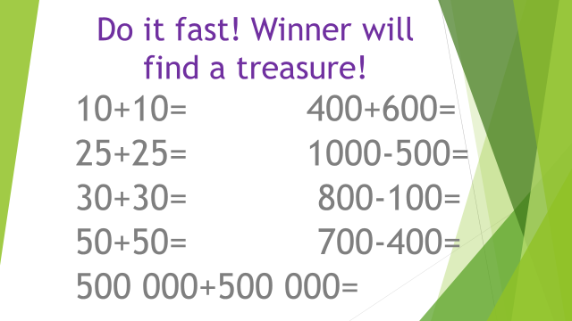  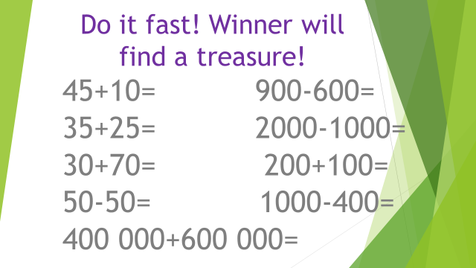 |  |  | 5 min
End | Award the winner group. Give sweets |  |  | 2 min
Assessment | Blob Tree  Draw a man where you feel yourself  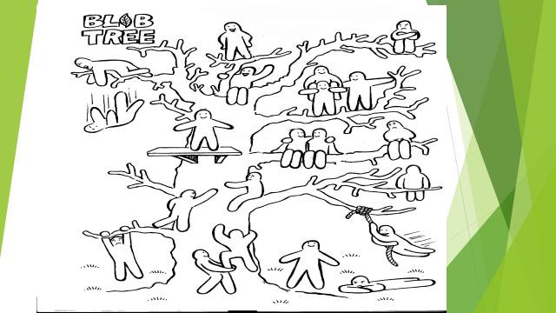 |  |  | 5 min
Additional information
Differentiation – how do you plan to give more support? How do you plan to challenge the more able learners? | Assessment – how are you planning to check learners’ learning? | Cross-curricular links Health and safety check ICT links  Values links
Reflection  Were the lesson objectives/learning objectives realistic?  Did I stick to timings?  What changes did I make from my plan and why? | Use the space below to reflect on your lesson. Answer the most relevant questions from the box on the left about your lesson
