Unit: 2 | Daily life and shopping
Teacher name: | Sirota Yuliya Valerevna
Date:
Grade: 8 | Number present: 10 | Number absent: -
Theme of the lesson: | Internet addiction
Learning objectives(s) that this lesson is contributing to | 8.R2. understand specific information and detail in texts on a growing range of familiar general and curricular topics, including some extended texts  8.S3.give an opinion at discourse level on wide range of general and curricular topics
Lesson objectives | All learners will be able to:  *identify specific information and details in a reading passage  *express thoughts about the given topic in the conversations  Most learners will be able to:  *analyze pros and corns of the Internet  Some learners will be able to:  *create a discussion about Internet addiction without support

Plan
Planned timings | Teacher's actions | Students` actions | Assessment | Resources
Beginning  5  minutes  Middle  35  minutes  5 min  7 min  3 min  8 min  2 min  10 min  Ending  5 minutes | Greeting.  Teacher greets students.  Warm up  Teacher shows the picture and says: -Look at the picture. What do you see? Brainstorm your ideas and guess the theme of our lesson.  Teacher introduces lesson objectives to students.  Pre-reading  Pre-teaching vocabulary  T→Cl→S1, 2…  Teacher presents the new words on the slide.  Pair-work. Match the words with their definitions:  Plays games Be network  Messages To occupy oneself in an activity for amusement or recreation  Online send short information personally  Internet a part of the internet where people can communicate by writing massages.  Chart rooms the global system of interconnected computer network  Reality be taken by post or email.  Virtual being on simulated on a computer or computer network  Psychologist Someone who likes to play computer games  Send Someone who studies the human emotions  Gamer the true situation and facts  Laptop the small computer that can you take with you.  After finishing learners exchange their works. The teacher gives the right answers. Learners check each other’s works.  Differentiation by resources in choosing the ICT technology that helps at translating words.  KWL -chart  Teacher: -We are going to read the article “Trapped in the net”. What do you know about it? Complete the KWL-chart.  What I know What I want to know What I’ve learned  Teacher monitors how learners work, helps less able learners.  While-reading  Ex. 1 p. 22 – 23  Teacher: -Read the article and fill the sentences in the missing words:  1.Jenny Foxton is a secondary school _________, but she’s also got another life.  2.Every night she turns on her laptop and visits a virtual world called__________, where users have created___________, rooms and communities.  3.____________ life on the internet is different, but also very time-consuming and obsessive.  4.Tom is often fighting battles with ogres on his_________.  5.This can happen to real_________, who often feel tired, depressed and___________.  6.___________ has ruined people’s___________, relationships and careers.  7.There are _________,advice and cures if you’ve got a_________  Differentiation by resources: Less able learners can use the dictionaries. More able students correct the false statements, less able students define True and False sentences.  Teacher monitors how learners work, helps less able learners.  Post-reading  KWL -chart  Teacher: -Complete the KWL-chart: the 3rd column.  What I know What I want to know What I’ve learned  Teacher monitors.  Differentiated tasks  Teacher distributes worksheets with multilevel assignments to students.  Level 1  Choose the right answer.  1.___________spends all night in the net.  a.Mary Barton b.Jenny Foxton c.Jim Tomas  2.Jenny Foxton visits a virtual world called _________.  a.World b.Warcraft c.Habbo  3.Tom Dobson’s plays________ online.  a.Minecraft b.World of Warcraft c.Dota  4.People are on the internet for forty-eight hours non-stop are_________.  a. sellers b.loosers c.addicts  5.Between_____________ per cent of internet users are addicted to the web.  a.five and ten b.three and five c.twelve and forty  6.____________ has ruined people’s education, relationships and careers.  a.Reading b.Cooking c.Internet addiction  7.According to psychologists internet addiction is a__________.  a.chance b.problem c.opportunity  Level 2  Define true (T) or false (F). Correct the false sentences.  1.Jenny Foxton is a High School student  2.She spends all night on the net  3.Tom is often sing a song in internet.  4.Tom has slept.  5.It can be cool to blog, chat, or play games online.  6.Internet addiction has ruined people`s education  7.There aren’t clinics, advice and cures if you`ve got a problem.  Level 3  Make up your own opinion about this text building on these questions.  1.What can you say about Jenny Foxton lifestyle?  2.What advice would you give to Tom Dobson?  3.How can online life destroy a person in his real life?  4.What are the positive and negative sides of the internet?  Level of thinking skills: Application  Descriptor  A learner:  -chooses the right answers  -defines T / F sentences  -corrects false sentences  -expresses own opinion  Differentiation by the tasks.  Teacher monitors how learners work, helps less able learners.  T: -Let's return to the lesson objectives.  -Have we reached the lesson’s aims?  Reflection  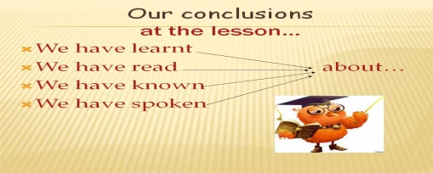 | Students respond to greeting and take their places.  Students express their ideas, then guess the theme of the lesson. (Internet addiction)  Students repeat the words after the teacher.  In pair students match the words with their definitions.  Students complete the chart.  Students read the text and do the task.  Students complete the 3rd column of the chart.  Students do the tasks.  Students complete the sentences evaluating themselves | Peer-assessment  Self-assessment  Formative assessment  “Thumb”  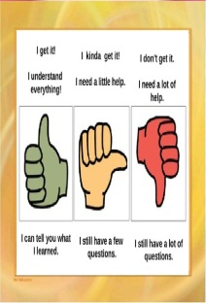  Formative Assessment  Formative  Assessment  Formative  Assessment  Self-assessment | picture  https://americanenglish.state.gov  PPT  worksheets  https://americanenglish.state.gov  SB: English Plus grade 8  PPT  https://americanenglish.state.gov  worksheets  worksheets  https://americanenglish.state.gov  worksheets

