Long-term plan unit: 8  Healthy habits |  | School: CSI “ Matay secondary school”
Date: |  | Teacher name: Kasenova Dinara Zhekeevna
Grade 7 |  | Number present: |  | absent:
Theme of the lesson: A radio interview.
Learning objectives(s) that this lesson is contributing to |  | 7.L8 understand supported narratives on a wide range of general and curricular topics  7.S7 use appropriate subject-specific vocabulary and syntax to talk about a range of general topics, and some curricular topics  7.C7 develop and sustain a consistent argument when speaking or writing
L Lesson objectives |  | All learners will be able to:
 |  | - Recognize the gist of a dialogue by little support
 |  | Most learners will be able to:
 |  | - Complete the graphic organizers
Some learners will be able to:
- Hypothesize and give arguments on developing health habiits
Assessment criteria |  | Demonstrate an ability to organize and express ideas clearly  Identify the gist of a dialogue using some supporting information  Communicate in a pair, group and a whole class work presenting  logically connected information with ideas of other people;
Value links: |  | Labour and creativity, cooperation, lifelong learning
Cross-Curricular Link |  | Biology
Previous learning |  | Health habits
Planned timings | Planned activities |  |  |  |  | Resources
Begin  3 min.  Middle  3 min  3 min  4 min  End  2 min | Organizational moment Teacher greets students and starts the lesson with the warm up activity: “Roulette” (I)  Learners spin the roulette and click on the corresponding box after stopping the roulette. Then share facts about their lifestyle by answering questions.  A descriptor:  a learner:  - answers the questions  Task . Listening  Pre - listening. Semantic Web (W)  Teacher writes the targeted vocabulary word in a box in the middle of the board and learners brainstorm to identify with the help of pictures all the words they can that relate to the target word.  Next, learners categorize the words.They label each list with the appropriate category title.  A descriptor:  a learner:  - completes semantic web  - categorizes the list with appropriate title  Listening.  Learners listen to a radio interview with Dr Anne Markham.  Post listening (G)  Group leaders choose one of the tasks then do them together.  Task 1. Manga bubbles. Fill in the gaps with the words from the dialogue.  A descriptor:  a learner:  - fills in the gaps with appropriate words.  Task 2. SWOT (strengths, weaknesses, opportunities and threats) analisys of Health habits. Do SWOT analysis using following questions.  Strengths: What are the benefits of healthy habits?  Weaknesses:List of weaknesses that can prevent of developing health habits.  Opportunities:What opportunities provides adoption of healthy habits?  Threats:What are the possiible threats in leading unhealthy habits?  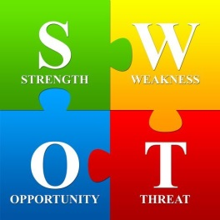  A descriptor:  a learner:  - does SWOT analysis of health habits  - defends his /her point of view  Task 3. Cause – and - effect tree diagram. Complete cause –effect tree by answering questions.  - What are the causes of developing healthy habits?  - What are the effects of healthy habits on health?  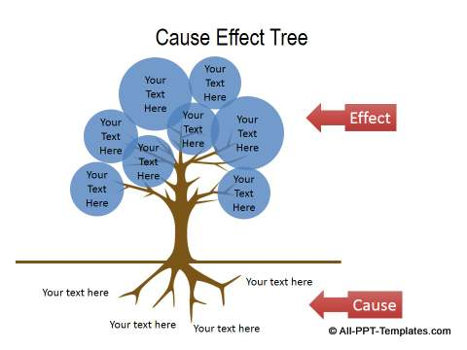  A descriptor:  a learner:  - completes the cause – effect tree diagram  - defends his/her position  Giving assessment feedback (F)  M&Ms  Teacher pours M&Ms candy into a bowl. Learners grab them and answer the questions  Red candy: What are two things you learnt ?  Green candy: What is the most interesting thing you’ve learnt?  Yellow candy: What was your favorite activity in class ? Why?  Orange candy: What was your least favorite activity in class ? Why?  Brown candy: How did this lesson make you feel and why?  Blue candy: What questions do you still have?  A descriptor:  a learner:  - answers the question, depending on its color. |  |  |  |  | PPT  PPT  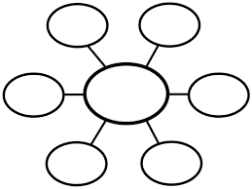  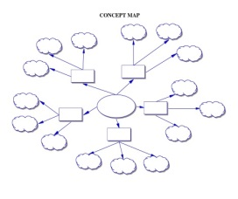  Audio materials  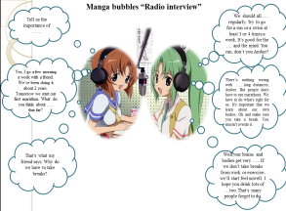  Charts  Diagram
End  1min | Feedback: Teacher asks students what task was difficult to them and which pair worked well.
Additional information |  |  |  |  | Health and safety check
Differentiation-how do you plan to give more support? How do you plan to challenge the more able learners?  Differentiation by task:  involve setting different tasks for students of different abilities.  Weak learners (complete the bubbles)  More able students (complete cause –effect tree diagram)  The most able learners  (do SWOT analysis of health habits ) |  |  | Assessment – how are you planning to check learners’ learning?  (F) Giving assessment feedback |  | Health saving technologies.  Using physical exercises and active activities.  Rules from the Safety Rules book which can be applied in this lesson.
By support during instruction and questioning phases of the lesson |  |  | Through questioning and the redirecting of questioning in feedback activities

