Technological сard №

І BLOCK «Aims and objectives»

Subject: Рhysics |  | Specialty: 0512000 «translation business» |  | Group: 15 | Date : 03.12.20
Lesson theme: |  | Light quanta. Photoelectric effect
Type of lesson: |  | combined lesson
Form of lesson: |  | learning new knowledge
The aim of the lesson: |  | Formulate the hypothesis of the Plank, summarize the formula and explain the phenomenon of photofrequency
Lesson objectives: | Educational: | Formulate the hypothesis of the Plank, summarize the formula and explain the phenomenon of photofrequency
 | Developing: | Developing students 'logical thinking and thinking skills by drawing up reports according to the theme, developing students' ability to express their thoughts accurately, to set specific questions and answer them clearly.
 | Bring up: | Educate the aspirations of students to gain knowledge by increasing their curiosity.
 | Professionalism: | Teaching to demonstrate pedagogical-psychological and integrative attributes of the teacher's competence, as well as the ability of the young teacher to be able to; development of creative search; development of intellectual and pedagogical competence skills.
Results of the lesson: | Basic: | - Opens the definition of "Light quanta", " Photoelectric effect ", "Intensity".  - Be able to make responsible decisions in difficult situations and demonstrate civil position.
 | Professional: | - Know the ways to improve the spirituality of the individual, add to his behavior, and improve his behavior.  - During the experiment, the essay on the topic can be associated with life.
Inter-subject communication: |  | English, mathematics, geometry, geography
ІІ BLOCK «Lesson equipment»
Recourses |  |  | Schemes, pictures, cards
Technical equipment |  |  | Computer, active board, tape-recorder, laptop
Information resource  Basic literature |  |  | - Physics Literature, A Reference ManualRobert H. Whitford and Robert L. Weber Citation: American Journal of Physics 23, 180 (2010);  - Published by the American Association of Physics Teachers Articles you may be interested in Physics in Literature Phys. Teach. 52, 22 (2014)
Additional literature |  |  | - https://infourok.ru/material.html?mid=31756  - https://helpiks.org/4-58752.html
Basic terms and concepts |  |  | light quanta, photoelectric effect, elementary particle, quantum mechanics, to propose, discrete, intensity, to remain, to gain, cut-off frequency
Techniques and methods of lesson: |  |  | Advanced training, critical thinking technology, question and answer method, reporting method, information collected from media, interactive methods: explanation, thinking, comparisons, analysis, information transfer, vocabulary;
Educational and methodical complex |  |  | Teaching-methodological complex for Physics.

ІІІ BLOCK «Lesson plan»
Stages | Methods of teaching | Outline of Lesson Plan
І. Organizational stage | Positive atmosphere | Greetings.  Inventory of students.  Psychological training in the classroom.
ІІ. Check your homework | LearningApps | Find the correspondence
 | Oral frontal | 1. How does the law of light propagation come into being?  2. What kind of law does this prove?  3. What is light ray, light bush, point light source?  4. Define light law.  5. What is mirrored, scattered reflection?
ІІІ. Brain Attack | Method of using the ICT | Look at the picture. What can you see?  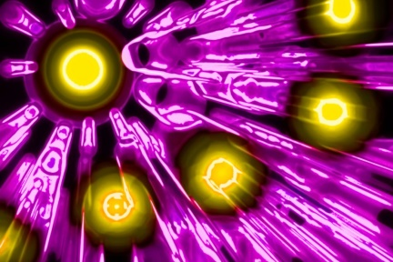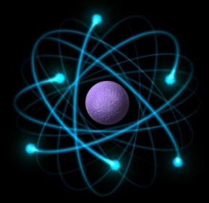  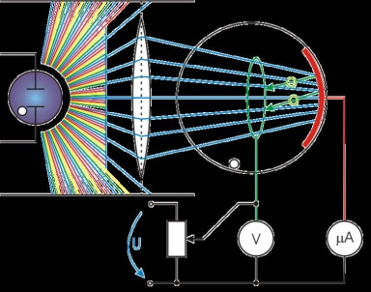
ІV. Learning new knowledge | Terminology | Presenting new lexical theme and new words  light quanta – жарық кванты  photoelectric effect – фотоэлектрлік эффект  elementary particle – элементар бөлшек  quantum mechanics – кванттық механика  to propose - ұсыну  Discrete – дискретті, үзікті  Intensity – интенсивтілік  to remain - қалу  to gain – ие болу  cut-off frequency – фотоэффектінің қызыл шекарасы  Simulation - модельдеу
 | Ask a question | Why are there no other colours in night vision?  Why do photographers use «photometer»?
 | Poster compilation | - Light quanta  - Photoelectric effect
V. Approve Lesson | LearningApps | Find the correspondence
 | Final assessment | What two things were successful (including teaching and learning)?  1:  2:  What two things has improved the lesson (including teaching and learning)?  1:  2:
 | Issue of reports | - Photon energy 2.8 * 10 ⁻¹⁹ J. What is the electromagnetic wave length?  - The light source of 100 W outputs 5 * 10²⁰ photons in 1 second. What is the average wave radiation?  - What is the electron magnetic wavelength, is the photon energy equal to 9.93 * 10⁻⁹ J?
 | Reflection | Reflection  I liked the lessons did not like the lessons
VІ. Assessment of the knowledge skills | «HAND»  evaluation method | After mastering the material, students defense the posters.  Evaluated by HAND:  content of the materials  - design, formalization  - full information  - correct information  exact information
VІI. Homework, indication of student's independent work |  | - Issue of reports  - Definition of terms

Theme: Light quanta. Photoelectric effect
Plan:
- Light quanta.
- Photoelectric effect
Max Planck found a way to cope with the interpretation of experimental results of thermal radiation
He proposed a daring hypothesis that contradicts the concept of classical physics in 1900:
Absolute black body does not emit or absorb continuous thermal radiation, but only releases or absorbs them in the form of contaminants. A portion of the radiation that is dispersed or absorbed is called energy quanta.
Quantum Latin guantum - meaning "size", ie "share".
M.Plank for a single contribution energy that absorbs or absorbs the body
E = hv
E is the smallest energy fraction of the v-ray frequency
h-Planck constant: h = 6,62 * 10 -34 J · hr
Thus, the body that emits or absorbs its energy in a continuous manner: 1E, 2E, 3E, nE.
The energy of the body changes only by one nucleus in quantum: En = nЕ = nhv
n - the number of photons that carry the energy of the electromagnetic radiation (the photon is the mass fraction of the atomic mass at zero);
E is the smallest fraction of each photon energy, ie one share of energy, that is, one quanta
According to the classical theory, energy changes continuously and can take any value from zero to infinity.
In contrast, Planck predicts that energy intersects and changes definite values.
Planck's scientific prognosis explains the phenomenon of thermal irradiation observed in absolute black body. E (λ) 2-curved experimentally constructed on the basis of the plan hypothesis is accurate with the 1-curve.
Planck's hypothesis has contributed to the founding of new quantum physics, which is called modern physics.
In 1887, German physicist Henry Hertz discovered that the electric sparks were rising and the electrical discharge would increase when the ultraviolet rays were emitted into the vibrator hole in which the electric sparks appeared. Then, when scientists dipped the ultraviolet radiation into the zinc plate, the negative charge emerges and the zinc reaches its positive charge.
These experiments show that the electrons are emitted from light when the metal plate is illuminated. Under the influence of such light, the appearance of electrons from the metal plate was called the photo effect.
It was a Russian physicist Stoletov who studied the phenomenon of this photo effect. Stoletov studied this phenomenon in the same manner.
Insert two electrodes (A (Anode) and (K) cathodes) into the absorbed glass balloon and add them to the power supply. When monochromatic radiation is absorbed in the K-cathode, the circuit breaks, and the circuit emerges as the electrons are removed from the cathode under the influence of monochromatic radiation. Under the influence of the electric field between the electrodes, the electrons separated from the cathode reach the anode. The circuit breaks out in the circuit. This lamb is called anode, or photo is called a current. As a result of different light emissions and radiation of the cathode wave lengths, Stoletov summarized the following laws.
1. Under the influence of light, only negative electrons are released from the cathode.
2. When the cathode has violet and ultraviolet rays, the effect of the photo effect increases.
3. The amount of electrons that emerge from the cathode will be directly proportional to the cathode surface lighting or the flow of light.
Used literature:
- Physics Literature, A Reference ManualRobert H. Whitford and Robert L. Weber Citation: American Journal of Physics 23, 180 (2010);
- Published by the American Association of Physics Teachers Articles you may be interested in Physics in Literature Phys. Teach. 52, 22 (2014)
- https://infourok.ru/material.html?mid=31756
- https://helpiks.org/4-58752.html

