Long-term plan:  Unit 3. Time |  |  |  |  | School: 18
Teacher name: |  |  |  |  | Yakupova M.A.
CLASS: 3 |  |  |  |  | present: |  | absent:
Lesson title |  |  |  |  | Days of the week
Learning objectives(s) that this lesson is contributing to |  |  |  | 3.1.8.1- understand short, narratives on a limited range of general and some curricular topics;  3.3.1.1- recognize, identify and sound with support a limited range of familiar words in simple sentences;  3.3.1.1- make basic statements which provide personal information on a limited range of general topics;  3.3.4.1- respond to questions on a limited range of general and some curricular topics;  3.5.1.1- plan, write and check short sentences with considerable support on a limited range of personal, general and some curricular topics;  3.5.14.2 - use prepositions of time: on, in, at to talk about days and times and no preposition last week etc.  3.6.9.1- use common present simple forms [positive, negative, question] and contractions to talk about what you want and like, habits and facts, simple future timetabled events;
Lesson objectives |  |  |  | All learners will be able to:  - listen and understand the names of the week with some support  Most learners will be able to:  - use new vocabulary  - answer the questions  - write and use new vocabulary  Some learners will be able to:  talk about timetabled events of the days of the week
Assessment criteria |  |  |  | A learner can  - fill in the table with present simple structure  - find the missing element  - write the days of the week with capital letters  - use preposition of time on in writing and speech  - say in right order the days of the week which come before/after  - make basic statements about weekly routine
Language objectives |  |  |  | Monday, Tuesday, Wednesday, Thursday, Friday, Saturday, Sunday, on
Previous learning |  |  |  | Daily routine
Cross curricular links |  |  |  | math
Values links |  |  |  | Common history, culture, language
Planned timings | Planned activities |  |  |  |  |  | Resources
Beginning  2-3min  1-2 min  2-3 min | T-P. Greetings:  T:-Good afternoon, pupils!  P:-Good afternoon, teacher!  T:-Sit down, please! How are you today?  P:-We are good!  T:-Who is absent?  P:-All are present!  (IW) Checking the home task  T:-What was your home task?  S:-Our home task was to learn the study spot on p. 37  T:- I’ll give the cards with the words, you need to read the words in cards and put the words on the right place  I you he she it we they  swim swim swims swims swims swim swim  Formative assessment sheet  Descriptor yes no  A learner puts the words on the right place  Warm up:  Phonetic drill  Onomatopoeic game  T:-Let’s play a game!  Let's tease the mosquitoes [z], [z], [z].  And the mosquitoes got angry and biting, and we say [ai], [ai],[ai].  And it hurts us [m], [m], [m].  We invite the squirrel for a walk [ei], [ei], [ei].  And let's show her how we knock dust out of the rug [d], [t].  Well done!  New theme  Teacher introduce learners with the new lesson and the aims of the lesson  Brainstorming strategy  T:-Look at the whiteboard and watch the video, please!  Now, guess the theme of our lesson!  P:-The days of the week!  T:-Right! Today we are going to talk about the days of the week, learn new vocabulary, play the “Before and After” game, study the preposition of time on, talk about timetabled events of the days of the week |  |  |  |  |  | flashcards with words  https://youtu.be/mmKFEqw-MkE
Middle  10-20 min  5 min | (W) Practice of new vocabulary  T:-Let’s watch the video and practice our new vocabulary  Game technology  Which day is Before/After game  T:-Look at the video and let’s guess which day is before or after.  Physical training  T:-Stand up and let’s do physical training Clap your hands  Grammar  T:-We write the days of the week with capital letter and use preposition on  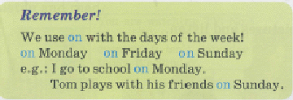  (PW) Task 1 Fill in the gaps  T:-Now, I’ll give you task with the days of the week, you need to fill in the gaps with preposition on and correct some mistakes, please work in pairs.  My name is Oleg. I am 11 years old and I live with my parents in a small town. Today I will tell you about my plans for a week.  As I’m in the fifth grade, from mondays to friday I have to go to school. monday is the most difficult day for me, ___ tuesday I am very busy. After school I have to play music.  __ wednesday I’m not as busy as ___ tuesday. On this day I often play football with my friends, help my Mother at home or go to the cinema.  thursday is my favorite day of the week because I have two lessons of English at school.  friday is almost the same as tuesday. Everything goes the same way but on Friday. I do my homework. __ saturday and sunday at 12 o`clock I go to my grandmother.  Peer assessment sheet  Descriptor yes no  fills in the gaps with preposition on  corrects some mistakes  Game technology  What is missing? game  T:-Look at the blackboard and remember the order of the days of the week, then close your eyes and I’ll hide one of the days of the week and you need to guess what is missing.  - Vocabulary practice.  - Unscramble the words:  unaydS  iayFrd  ueayTsd  yanMdo  uayThrsd  auayStrd  sdWneayde  Differentiation by task  Task2.Find the English equivalents to the Russian phrases for weaker learners  Formative assessment  Pupils draw a line to the correct answer  1) Четверг a) Monday  2) Понедельник b) Tuesday  3) Суббота c) Wednesday  4) среда d) Thursday  5) Вторник e) Friday  6) Пятница f) Saturday  7) Воскресенье g) Sunday  key: 1-b 2-e 3-d 4-a 5-f 6-c 7-g  Task read and correct for the stronger learners  1.Liam don’t play the guitar.  2.Where does they go on Friday?  3.What time do you gets up?  4.Lilly drink milk in the morning.  5.Lilly and Charlie doesn’t like burgers.  6.They plays football every day.  7.Does you play the violin?  8. He don’t go to school on Sundays  FA: teacher assesses learners by oral comments  (GW) Task4 Poster time  T:- I divide learners into 2 groups, 1 group must correctly distribute the days of the week as in America and the second group as the days of the week begin in Kazakhstan and paste on the poster.  Group assessment sheet  Descriptor yes no  Distributes correctly the days of the week in America and Kazakhstan  T:-Thank you very much, my dear children, for your hard work. Your home task will be learn 7 days of the week |  |  |  |  |  | https://youtu.be/fSWfRL3LKm0  https://youtu.be/fSWfRL3LKm0  https://youtu.be/Jw2RHq82sYU  PPT 1  sheets with task  flashcards of the days of the week  PPT2  PPT 3  Poster
End  5 min  2 min | Feedback  What we have done today?  What have you known today?  Do you know something new from the lesson?  Do you like our lesson?  Teacher asks learners to show their thumbs –up/down  It will be a quick way to check for understanding and keep the learners involved in the learning  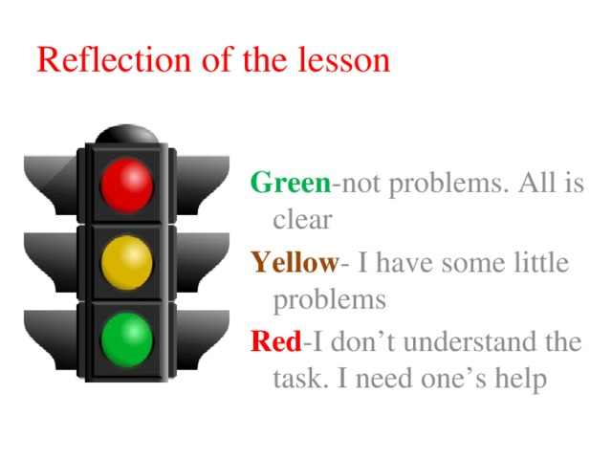 |  |  |  |  |  | PPT4
Additional information
Differentiation – how do you plan to give more support? How do you plan to challenge the more able learners? |  |  | Assessment – how are you planning to check learners’ learning? |  |  | Health and safety check  ICT links
Differentiation achieved through pair work, group work  It gives learners more thinking time, it develops their communication skills, visual memory. |  |  | 1 Self-Assessment in feedback  2 Peer-Assessment in groups  3 Formative Assessment checking home task and in doing exercises  4 Group assessment in poster time activity |  |  | use the interactive whiteboard for 15 minutes  use the physical training and active activities
Reflection  Were the lesson objectives/learning objectives realistic?  What did the learners learn  today?  What was the learning atmosphere like?  Did my planned differentiation work well?  Did I stick to timings? What changes did I make from my plan and why? |  | Use the space below to reflect on your lesson. Answer the most relevant questions from the box on the left about your lesson.
Summary evaluation

What two things went really well (consider both teaching and learning)?

1:

2:

What two things would have improved the lesson (consider both teaching and learning)?

1:
2:

2:

What have I learned from this lesson about the class or individuals that will inform my next lesson?

