Three cheers for Pooh

Aims To develop listening, writing, speaking and reading skills

Teacher Akramkhojayeva R.Z
Grade 6 A

Introduction 3 min
Good afternoon dear pupils
Today we have very interesting theme for our lesson
Can you guess it?
Yes , you are right
Today The theme of our lesson is Three Cheers for Pooh

Beginning
First task 5 min
Do you Know th days of the week? Fit them into the grid

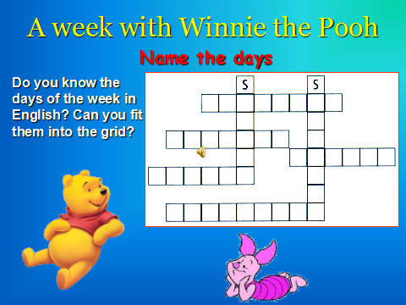 group assessment
- Monday 5 min
Match the parts of the names

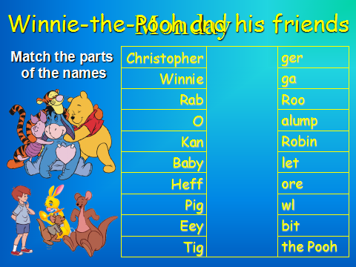 jury assessment
4 Tuesday
Make up sentences using these words 5 min

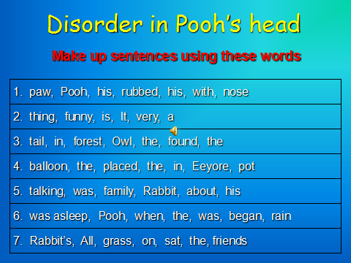 jury assessment

5 Wednesday
Find words 5 min

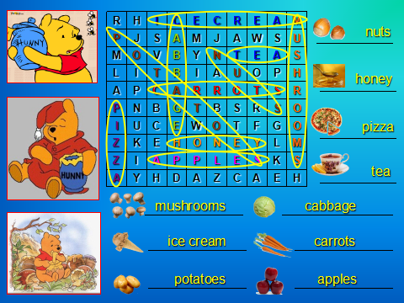 jury assessment
Thursday
Write correctly 5 min

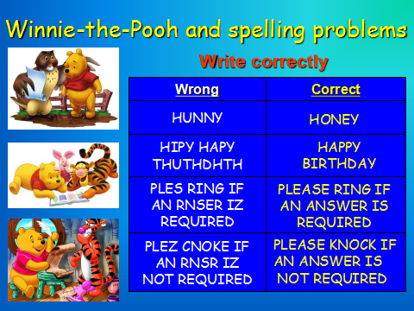 jury assessment

- Friday 2 min
Sports activities
Write missing letters
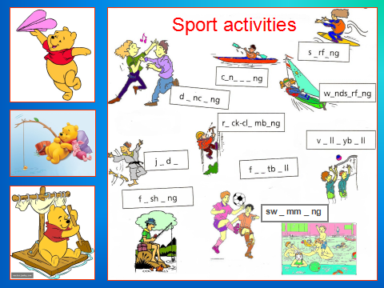 jury assessment

Saturday 5 min

Colour Winnie the Pooh and his friends

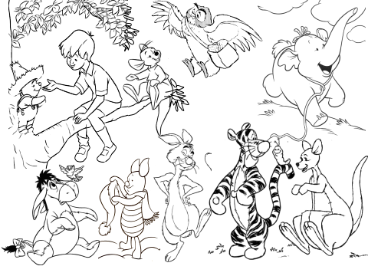 jury assessment

Sunday 5 min

Tongue Twisters
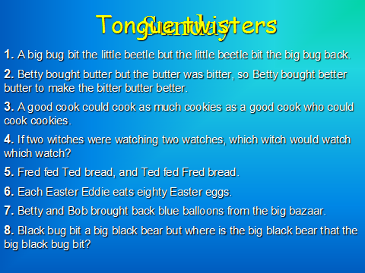 Pair assessment

While jury is deciding who is the winner teacher Asks pupils if they like this lesson
When get diploma

